Information Systems and Technology Security
Change Advisory Board Charter

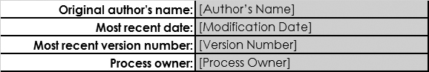

Document History
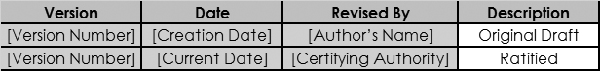
Copyright © [Creation Date] [Company Name]

All rights reserved. This document is for internal use only. No part of the contents of this document may be reproduced or transmitted in any form or by any means without the expressed written permission of [Company Name].

Change Advisory Board Charter
The intent of the Change Advisory Board Charter (Charter) is to establish a common understanding of the function, roles, and responsibilities of the Change Advisory Board. Adoption of the Charter indicates agreement with the purpose and overview as described herein. Each Change Advisory Board member agrees to rely on the Charter as the basis for determining and fulfilling all actions executed on behalf of the Change Advisory Board. The Charter will be reviewed and approved annually by the Company Chairman or its designee.

- Scope
The Change Advisory Board (CAB) is established to communicate, coordinate, and certify all changes that are scheduled to be implemented into the Information Technology (IT) production environment within [Company Name]. This task is accomplished by providing a forum; whereby, representatives from all IT areas are made aware of changes that could directly, or inadvertently, impact their respective areas. By openly discussing these changes prior to implementation, this allows IT to be more proactive, as opposed to reactive, in regards to the preparation of the deployment and implementation of change. The CAB also aids in the compliance with fundamental audit practices as they pertain to the receipt and review of approvals of the changes prior to implementation into a production environment. The CAB will channel all changes through a centralized location from which any information regarding changes can be easily attained.

- Requirements
The CAB shall meet weekly and will be facilitated by a representative of the Information Systems and Technology Security (InfoSec) group. The InfoSec representative will provide the CAB with the meeting agenda, meeting minutes, and a weekly CAB report. All information provided in the CAB report is extracted from the Support Request System after [Time] on each [Day of Week] prior to the weekly, Friday meeting. For more information, please refer to the Meeting Agenda section of this document.

  - Membership and Attendees

The CAB will be composed of members from Senior IT Management with representation from each major IT Division with tie breaker authority from the Chief Information Security Officer. The meeting cannot take place unless the majority of voting members are in attendance.

  - CAB Members

- Chief Security Officer, Chair *

- Chief Information Officer *

- Chief of Product Development *

- Infrastructure Team Leader

- CAB Attendees

- Individuals in the IT Change Control distribution group which were not previously listed above.
* Denotes Voting Members

  - Meeting

The CAB members may approve or reject any request, as they deem necessary. A majority of the voting members or designates in attendance will be required to approve any and all business presented to the CAB.
The InfoSec representative will certify each change control tickets Request that meets the criteria for certification. This will signify approval for the project implementation. Any member of the CAB may request additional testing, training, evaluation or other tasks necessary to ensure a successful implementation. The scope of such additional tasks must be defined with an agreed upon completion date.
Minutes to record attendance of the voting CAB members and decision(s) will be archived on the Company [Company Work Order System] for historical reference and evidence of review for change control purposes.

  - Meeting Agenda

The following table outlines the general weekly agenda for the weekly CAB meeting. The specific weekly agenda, minutes, and CAB report will be distributed prior to each weekly meeting.

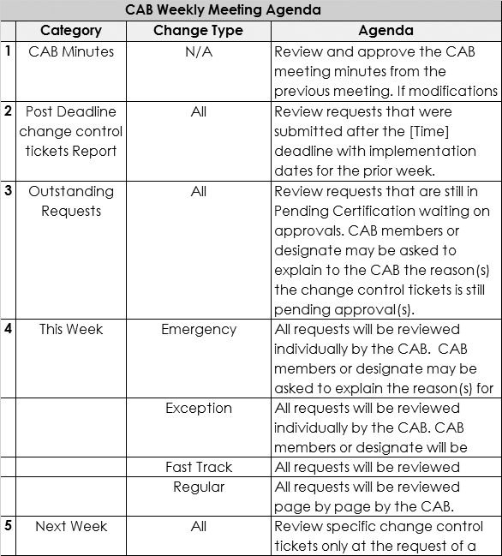
The meeting facilitator will request that a voting member make a motion to accept the CAB report as presented, along with all noted modifications. A second will be requested and a vote of all members will be taken with objections documented.

- Responsibilities
The [Security Executive's Supervisor Title] or its designee is the approval authority for the Change Advisory Board Charter.
The [Security Executive's Title] is responsible for the development, implementation, and maintenance of the Change Advisory Board Charter and associated standards and guidelines.
Company management is accountable for ensuring that the Change Advisory Board Charter and associated standards and guidelines are properly communicated and understood within their respective organizational units. Company management is also responsible for defining, approving, and implementing procedures in its organizational units and ensuring their consistency with the Acceptable Use Standard and associated standards and guidelines.
All individuals, groups, or organizations identified in the scope of this policy are responsible for familiarizing themselves and complying with the Change Advisory Board Charter and associated standards and guidelines.

- Enforcement and Exception Handling
Failure to comply with the Change Advisory Board Charter and associated standards, guidelines, and procedures can result in disciplinary actions up to and including termination of employment for employees or termination of contracts for contractors, partners, consultants, and other entities. Legal actions also may be taken for violations of applicable regulations and laws.
Requests for exceptions to the Change Advisory Board Charter should be submitted to the [Company Name] [Security Executive's Title]. Exceptions shall be permitted only on receipt of written approval from the [Security Executive's Title]. The [Security Executive's Title] will periodically report current status to the [Company Name] [Security Executive's Supervisor Title] or its designee.

- Review and Revision
The Change Advisory Board Charter will be reviewed and revised in accordance with the Information Security Program Charter.

Recommended: ________________________
Signature
[Name]
[Security Executive's Supervisor Title]

Approved: ____________________________
Signature
[Name]
[Security Executive's Supervisor Title]

